MEDIA RELEASE
10 July 2020

Australia delivers 25,000 essential PPE to Solomon Islands
Australia has provided Solomon Islands with 25,000 much-needed medical gowns, an essential component of COVID-19 Personal Protective Equipment (PPE).
The gowns are enabling medical officers and government officials to safely conduct COVID-19 quarantine procedures. Proper PPE has been vital in Solomon Islands’ efforts to contain and prevent any spread of coronavirus, particularly when hundreds of passengers are entering the country through quarantine centres.
PPE gowns are categorised across three different classes – according to the type of response required in a COVID crisis. Australia provided 20,000 ‘level one’ gowns currently being used by frontline health and quarantine officials and 5,000 ‘level three’ gowns, to be worn during serious surgical procedures.
The PPE has been delivered on a number of Solomon Airlines cargo flights over the past few weeks, including a batch on a flight on Friday afternoon (10 July). The PPE are now being kept at the National Medical Stores in Ranadi.
Australian High Commissioner Dr Lachlan Strahan handed over boxes of PPE to the Director of Pharmacy Services Timmy Manea, at the National Medical Stores on 10 July.
“Without adequate PPE for people working in front-line quarantine and medical roles, it would have been impossible to bring people home to Solomon Islands,” Dr Strahan said.
“Australia is pleased to be assisting Solomon Islands by delivering these vital medical supplies for COVID-19 preparedness and response.
“Most of the gowns will be used in Honiara, which is the main entry point into Solomon Islands, but some will be distributed to medical stores around the country to ensure that COVID preparedness and response is strengthened in the provinces.”
Permanent Secretary for Health, Ms Pauline McNeil, expressed her gratitude for the ongoing support received from Australia towards the COVID-19 preparedness and response activities.
“We are grateful for Australia’s responsiveness to our requests for assistance across different areas of our COVID-19 response planning,” Ms McNeil said.
“This PPE is critical to protect our frontline medical officers and quarantine officials. Procuring these supplies has been challenging due to high global demand, so this large supply from Australia is a huge help to our efforts to bringing so many of our people home to Solomon Islands.”
Australia’s PPE delivery is in addition to other substantive COVID support to Solomon Islands including establishing laboratory testing capability by funding a qPCR machine and consumables, GeneXpert testing cartridges, the refurbishment of the molecular laboratory at the National Referral Hospital, and two new pre-fabricated quarantine units at the airport.
Australia also provided an additional SDB71 million to the Solomon Islands Government to help sustain its health response and assist with managing the economic impact of COVID-19.

ENDS//

For media enquiries: Australian High Commission Solomon Islands Media Unit, Phone 21561 ext. 139, SIMediaUnit@dfat.gov.au
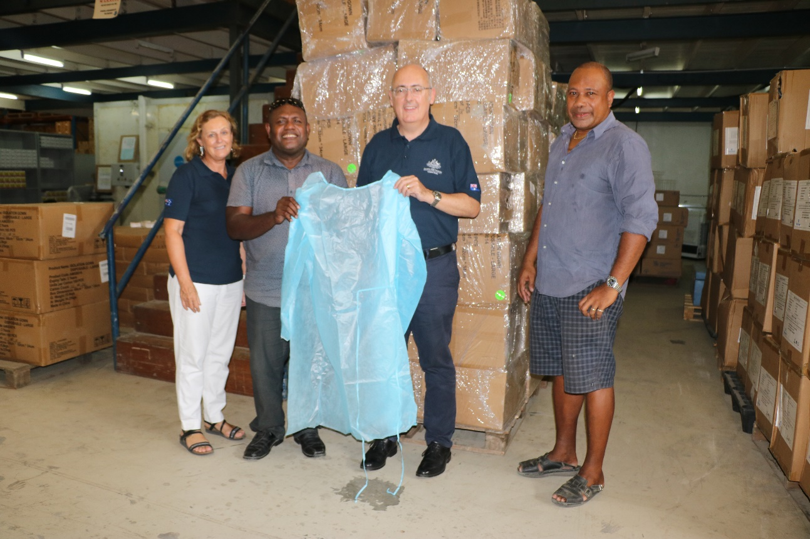

Australian High Commissioner Dr Lachlan Strahan and Counsellor Human Development Julie McCallum officially hand over the new gowns to medical officials at the National Medical Stores

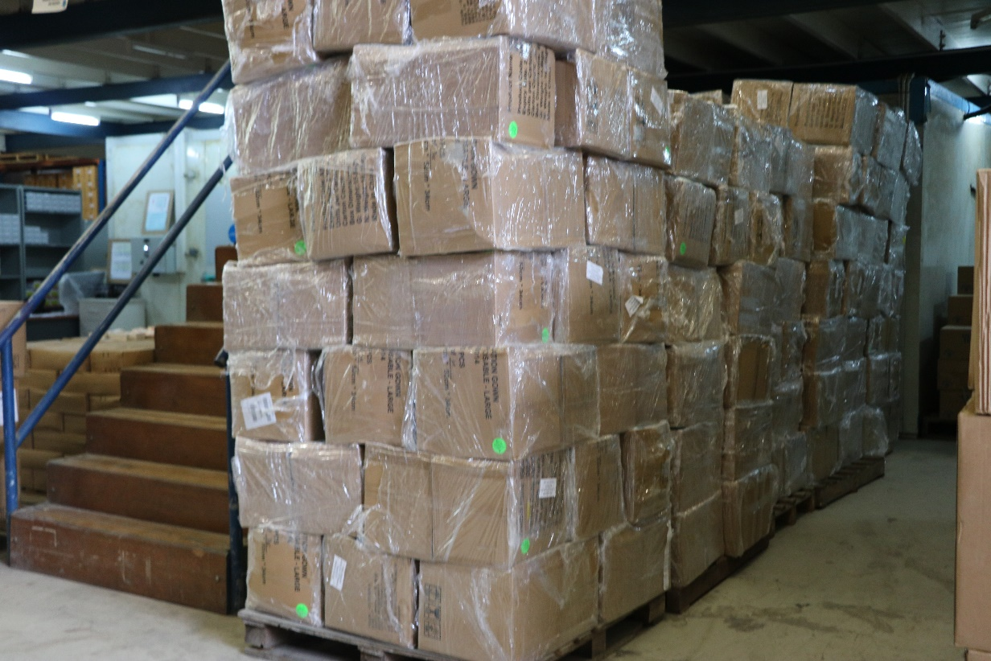

Boxes of PPE from Australia at the National Medical Stores

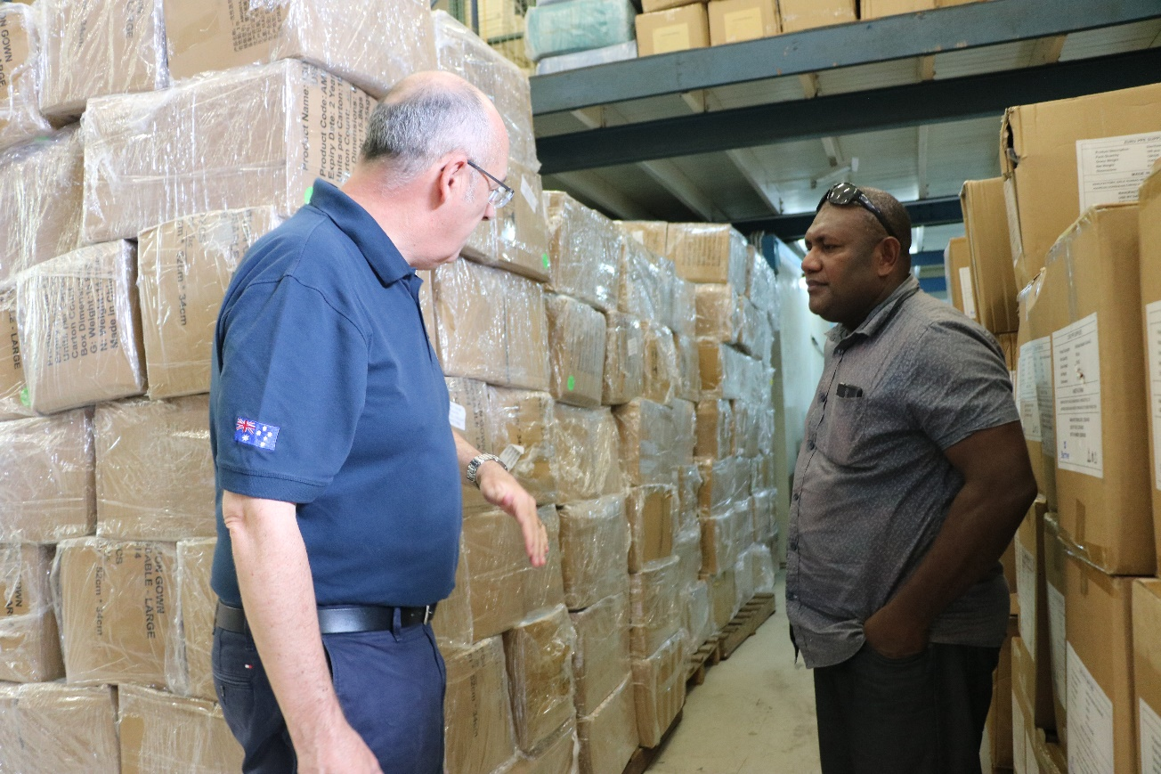

Australian High Commissioner Dr Lachlan Strahan with the Director of Pharmacy Services Timmy Manea

